
What is TOAD?

- TOAD (Tool for Oracle Application Developers) is a database development/administration tool with especially deep support for Oracle databases. It’s basically a Database IDE like DBeaver.
  - Despite its focus on being THE tool for Oracle databases, it has support for other popular flavors like PostgreSQL or MySQL.
  - Like DBeaver, TOAD aims to make it easier to perform common database interactions like queries, manipulations, or debugs.
    - It also has advanced features for optimizing databases, such as query tuning, performance diagnostics, and automated code analysis. This is how they justify charging users I suppose. No comment since I haven’t gotten a chance to use it :)

- TOAD isn’t free like DBeaver. So, chances are you won’t really be using TOAD unless you’re working with Oracle DBs with your team. We’ll stick with Dbeaver and SQLite for our training.

- It has a great domain name - https://toadworld.com/
  - Click that link if you want, cause TOAD does have a few different offerings. But the Oracle DB niche is still its bread and butter.
  - 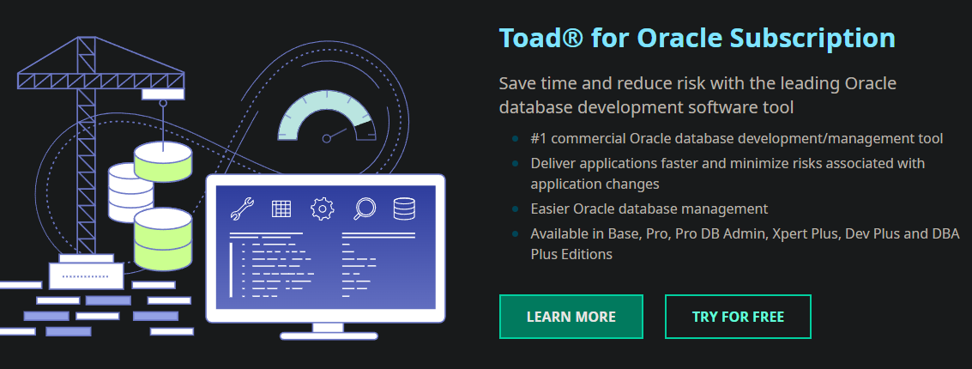
(This is the first thing on the list of offerings)

